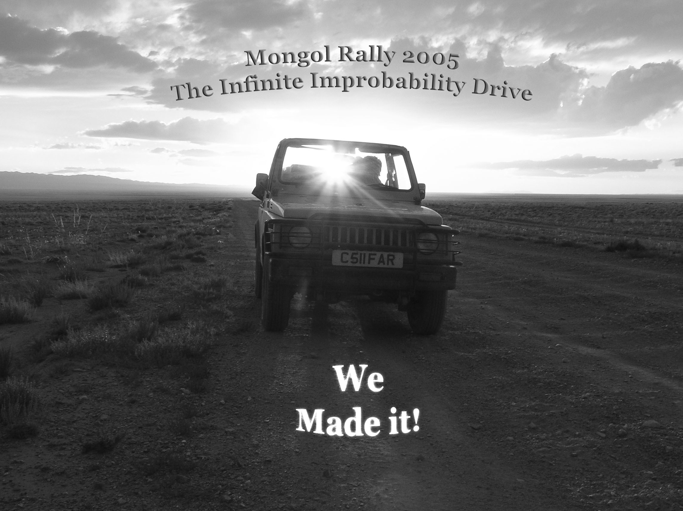

The Old School House
Drumelzier
By Biggar
ML12 6JD

Dear

Well, we made it. 9000 miles, 17 borders and 27 days took us from Hyde Park to Ulaan Baatar. This is a brief synopsis of some of our adventures, and a huge thankyou for sponsoring us. As things stand we have now raised about £5000 for the two charities, Save The Children and Send A Cow, which is absolutely fantastic. The rally as a whole has raised over £50 000. Hopefully our slightly daft trip will make some small difference to other people’s lives.

The rally left from Hyde Park on the 30th July, approximately 44 teams managed to make it over the start line. First stop was Dover, where the first rally casualty was taken, the Reliant 3 wheeler, apparently blew up and, with no little ignimony, was able to go no farther. From Calais it was a long push to Prague, motorway all the way. Our wonderful machine wasn’t happy doing anything over 55mph, so it was 750 miles before we actually managed to overtake something and even that re-overtook us as soon as we got to the top of the hill. Once in Prague we were meantg to find a small café and sign in. This took over 2 hours of floundering around the fiendish one way system, all the while mistaking police cars for rally cars and honking at them, and unsettling the locals with unscheduled detours onto crowded tram platforms. From Prague our next stop was in Bulgaria, passing swiftly through Slovakia, Hungary and Serbia on the way. It was the first place that was genuinely beautiful, after the great flat monotony of Eastern Europe, and we stayed with some friends up in the mountains. The next day we managed to get wonderfully lost because I was far to engrossed in Harry Potter to pay any attention to the map, and very nearly ended up in Greece rather than Turkey.

We joined forces with another team, Chris and Dave in the Buzzwagon, who were cunningly driving exactly the same sort of machine as us. If you have as little mechanical expertise as the four of us did then it pays to pool your resources, particularly when driving 20 year old jeeps. Istanbul was the next target, its an absolutely fantastic city, heaving with life and history, and indeed it rather marked the point at which the rally really started. Europe is like a warm up band picked solely to make the headliner look better, the odd perky moment but really not that exciting. The driving in Istanbul is also absolutely terrifying, the only way to survive is to be massively aggressive, which was the perfect excuse to drive as badly as we possibly could, and get away with it. Fantastic fun!

From here we headed to the north coast, which was stunning with tree coated hills running straight down into the sea, lots of steep roads and hairpin bends to keep us occupied, particularly at night and all manner of animals and humans wandering in the middle of the roads to dodge. The later stages of Turkey were rather afflicted with urban sprawl, it is a much bigger and more developed country than I had somehow imagined it, but it passed without great incident. We then crossed the border into Georgia, and an immediate change in people, scenery

