Sponsor The 2005 Mongol Rally

The Old School House
Drumelzier
By Biggar
ML12 6JD
Dear

The Mongol Rally, a slightly eccentric adventure, sets off on 30th July this year. Approximately 50 cars, each with an engine size not exceeding 1 litre, are attempting to drive nearly 10 000 miles, 1/3 of the way across the world’s surface, from London to Ulaan Baatar, the capital of Mongolia. I, along with my co-driver Harry Caldecott, shall be joining them. We have christened our team ‘The Infinite Improbability Drive’. It promises to be not so much Mongolia or bust as Mongolia while mostly bust. The route will take us through Central Asia; one of the least travelled yet most intriguing areas of the world. The roads will often be unsurfaced, except in Mongolia where there won’t really be any roads at all. We have just acquired a car, a Suzuki SJ410, which is 4WD, has a huge 970cc engine, a soft top and is a rather spectacular green colour. Initial tests suggest it makes driving along even the smoothest of surfaces seem as if you are off-road. It will not be easy: maps, mechanics and manners will all play a part, as well as a simple determination to get there somehow.

There is a serious element to this letter, the principal aim of the rally is not just to put ourselves in ridiculous situations and then see if we can get out of them again, but in fact to raise as much money for charity as we possibly can.

The Charities
The rally this year is being run in aid of two very worthy causes, the first is a charity called Send A Cow and the second is Save The Children’s projects in Mongolia. Send A Cow is an excellent charity that gives cross-bred cows, with a much higher milk yield than their native equivalents, to poor families in African countries including Ethiopia, Kenya, Rwanda and Uganda. Not only do these cows help combat malnutrition but also fertilise the land and produce a surplus of milk. This can be sold and the money then used for the education of the family’s children or investment in other money making schemes. The first female calf is passed on to another family in need. Training is also given to those provided with a cow. In cases where a cow would be unsuitable other livestock, for instance chickens or goats, are used.

Save the children provide a drop-in centre in Ulaan Baatar for homeless children, in a country where 1/3 of all children live in poverty. Here they provide food, water, clothes and have doctors on hand to teach the children about looking after themselves and recognising when they are ill, apparently quite a problem. Other projects include the establishment of kindergartens for the estimated 2/3 children without access to a preschool education, and several more besides.

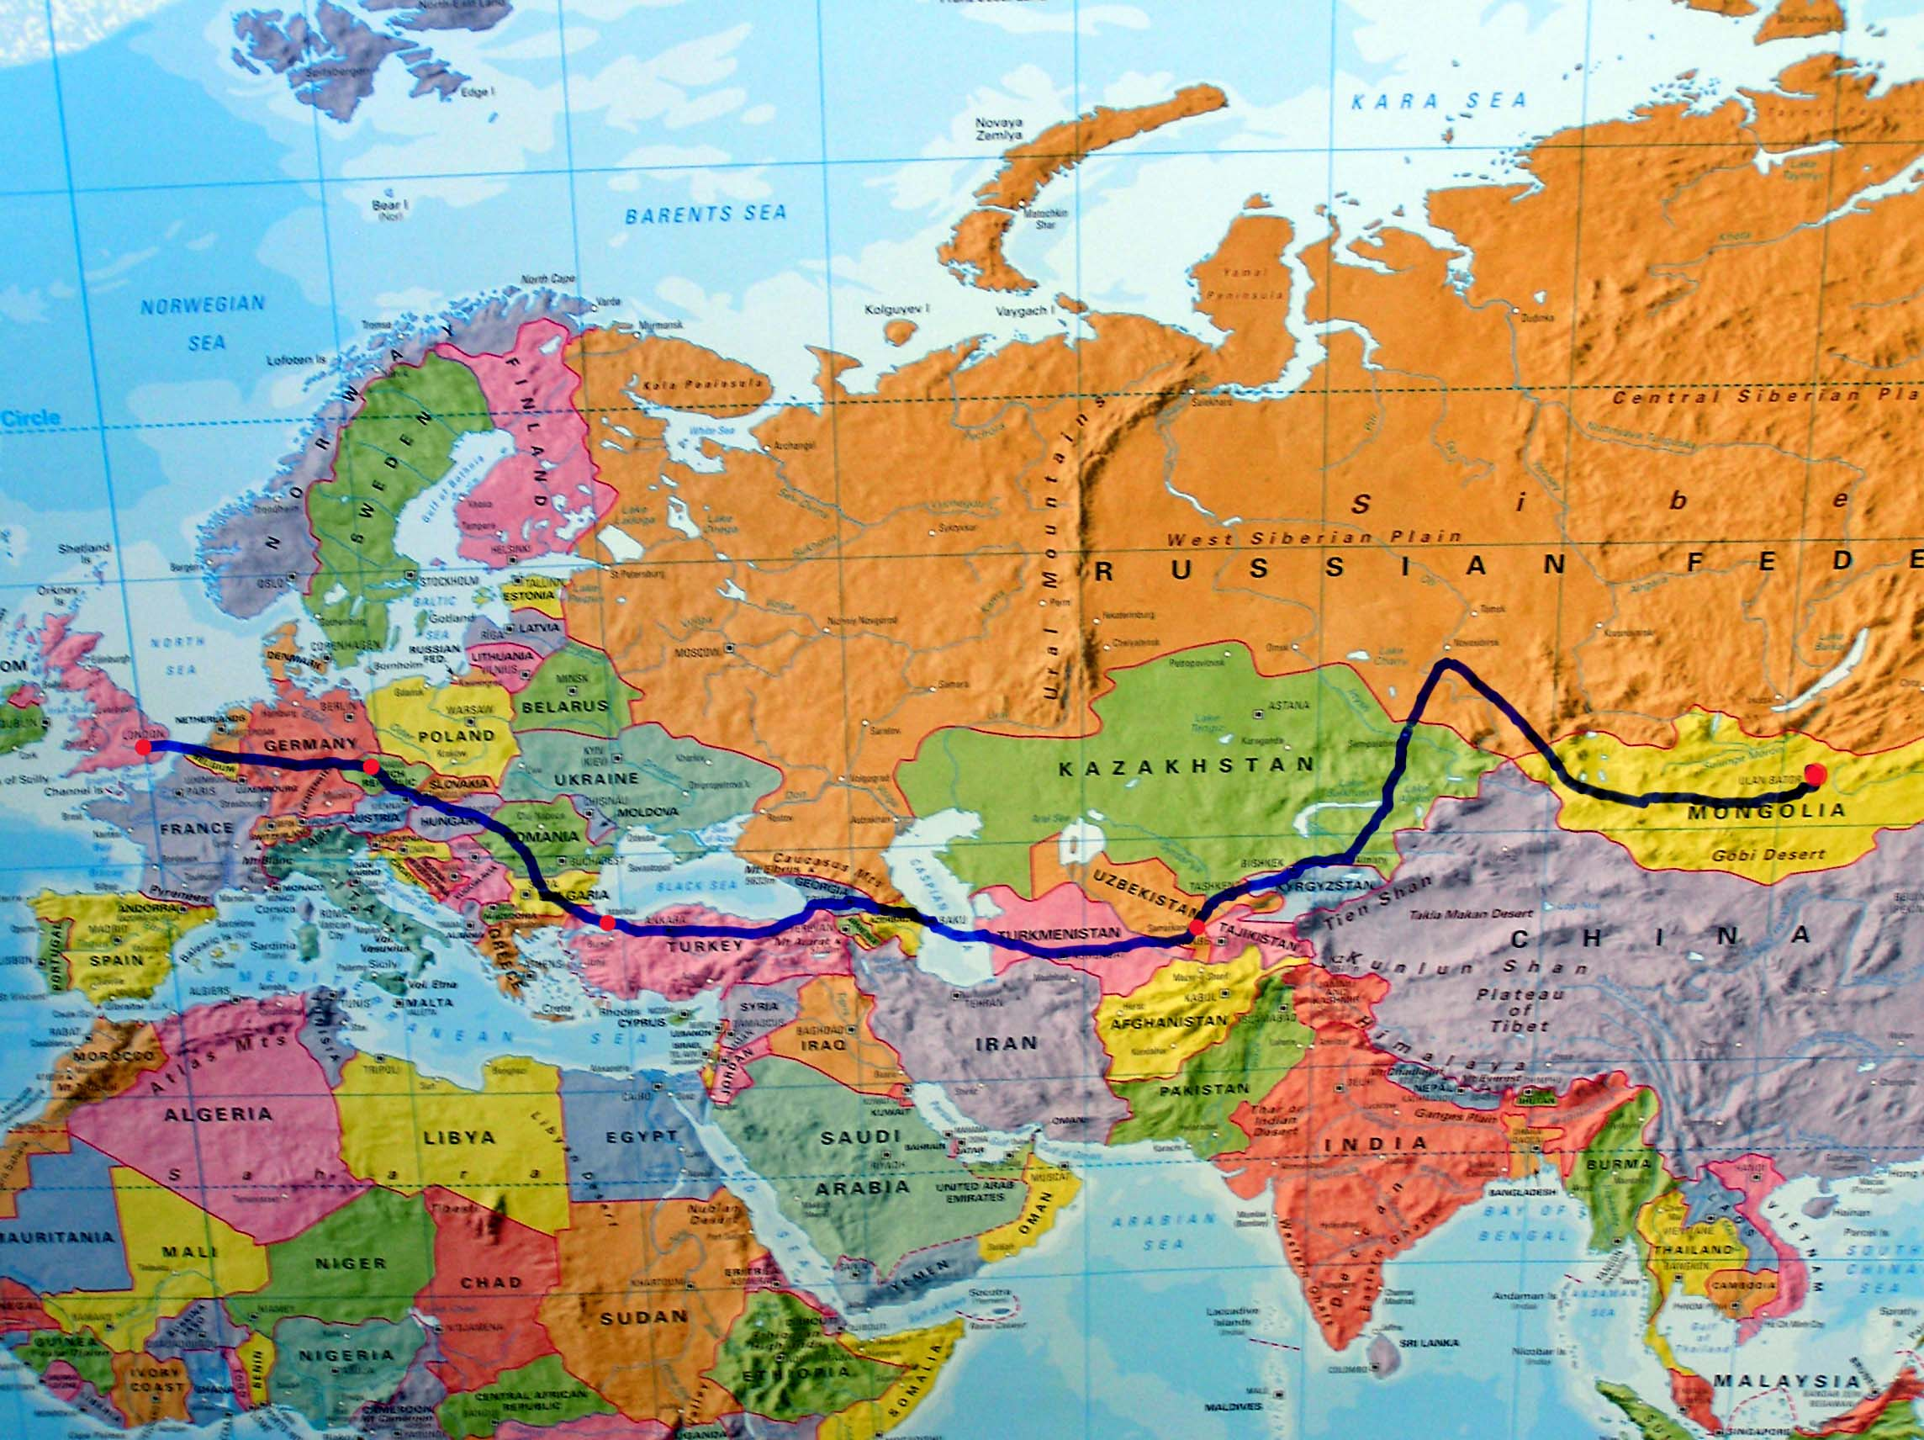
The Route
The rally will set off from London on the 30th July. Having negotiated the channel we will initially make for Prague, pause and refuel. From here the rally splits into 3, the bureaucracy loving go to Moscow, the indecisive to Kiev and the conflict hungry to Istanbul. We shall be following the southerly route, from Turkey going via Georgia and Azerbaijan then crossing the Caspian Sea by boat and landing in Turkmenistan. We shall be travelling in the realms of the silk route. In between our major stopovers pauses will be few, well the deliberate ones anyway. Essentially one of us will drive while the other sleeps, then vice versa, through the nights.

All surviving ralliers will then converge on Samarkand, in Uzbekistan, perhaps the most evocative name in Central Asia. From here the final rush for Ulaan Baatar begins, we go north through Kazakhstan into Russia, then make a sharp right turn and attack Mongolia from the west, the rusting horde turning their charge towards the land Chinngis Khan himself. From here the most accurate description of the roads is ‘migratory’. They are never more than dirt tracks, road signs are about as common as zebra crossings and the advice generally involves following the power lines if you can find them or to use the wonderfully named GPS, the Ger Positioning System. The ger is the semi-permanent tent that the nomadic population of Mongolia still live in, positioning involves going up to them to ask the way, despite inevitably not understanding the response. Anyway, with luck sometime towards the end of august we will roll into Ulaan Baatar and be allowed to go home again. The cars are donated to charity in Mongolia. When phone reception allows we will be texting regular updates on our progress to our team page on the rally website, where they should be published automatically.
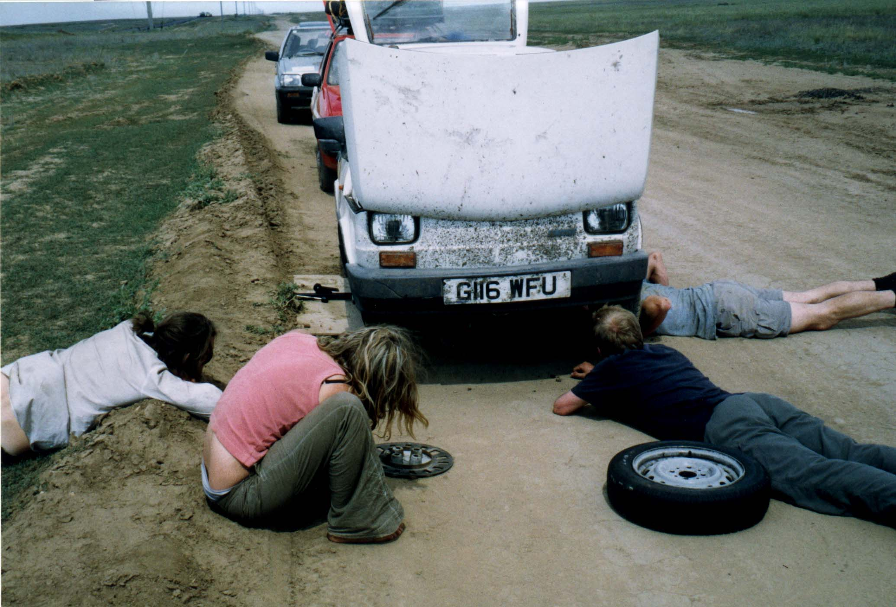

The Sponsorship Drive
We have come up with a couple of ways of persuading you to part with some pennies. The first is to sponsor us an amount for every border we manage to cross. The second is, in the spirit of the rally, the chance to sponsor parts of our car. I have created a sliding scale of car parts, the greater the impedance to our progress in losing one of these the greater its value. Feel free to sponsor any combination of these you like, or alternatively choose your own and donate the sum you feel best represents it. If we can work out how we will then set up a website and credit our sponsors. There is also space on the bodywork of the car for anyone who would like to pay to stick stickers on it.

The rally has been featured in a variety of publications, varying from Top Gear magazine to the Ulaan Baatar Post. Another flurry of publicity can be expected around its departure.

More Information
Still intrigued? The Internet will be the place then.
www.mongolrally.org.uk is our very own site, come here to find as much information as we have, any news, and the chance to enter our competition!
www.mongolrally.co.uk is the excellent official rally site, and the place from where you will be able to follow our progress once we set off. Just go to the team page then click on The Infinite Improbability Drive. It’s also the place to go if you want to come too.
www.sendacow.org.uk is fairly self-explanatory
www.savethechildren.org.uk is their main site.
www.savethechildren.mn is the one specifically focussed on Mongolia.
www.justgiving.com/infiniteimpossibilitydrive our online piggy bank, donate here and the government gives us an extra 28% in tax through the Gift aid scheme, which is surprisingly kind of them.

Contacting us
Donations should be directed towards me at the above address, or at our page on justgiving.com, where it is possible to donate by credit card. Any questions can be thrown at me via
Email: archie@mongolrally.org.uk
Mobile 07769695686 Home 01899830282

Many thanks for your time

Yours,

